STUDENT NOMINATION FORM - Fall 2017
Model Marauder Awards for Excellence and Creativity

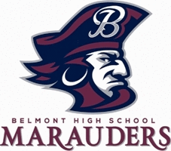

Student Award: BHS students are eligible to be nominated for a Model Marauder Award for Excellence and Creativity in the areas of scholarship, art and citizenship.
- Students can be nominated by staff members.
- All nominations will be reviewed by a committee of staff members, who will forward 3 finalists for each category to the school administration.

Prospective Model Marauders will be evaluated on the following 6 criteria:
- Demonstrating a willingness to innovate, experiment and build on new ideas.
- Developing, implementing and communicating new ideas to others effectively.
- Incorporating feedback into their work, demonstrating openness and responsiveness to new and diverse perspectives.
- Demonstrating originality and inventiveness in their work.
- Viewing failure as an opportunity to overcome challenges and learn to be resilient.
- Acting on creative ideas and making useful contributions to their school and community.

NAME OF STUDENT (being nominated):___________________________________________

STAFF MEMBER (making the nomination):_________________________________________

STATE REASONS BELOW for NOMINATION this STUDENT
(Please be specific, give examples to support the nominee, see criteria above, attach separate paper if you need more room to support you nomination):

DEADLINE TO NOMINATE: Friday, December 22, 2017
Return to Mr. Brow’s Mailbox in the BHS Main Office and/or email: tbrow@belmont.k12.ma.us

